1. Create a database **<yourname>dbms3**



1. Use Current Databse: **USE <yourname>dbms3**



1. Create table
2. student (id, name,gender,program,contact_number,address)

**Qurey: CREATE TABLE student (id INT, name VARCHAR(100), gender VARCHAR(10), program VARCHAR(50), contact_number VARCHAR(15), address VARCHAR(100));**



1. teacher (id, name, subject, contact_number, address,email)

**Qurey: CREATE TABLE teacher (id INT, name VARCHAR(100), subject VARCHAR(10), contact INT(20), contact_number VARCHAR(15), address VARCHAR(100),Email VARCHAR(50));**

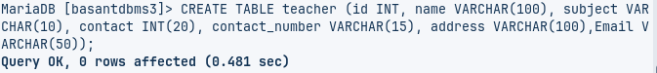

1. See detail of Tables
2. **DESCRIBE student;**

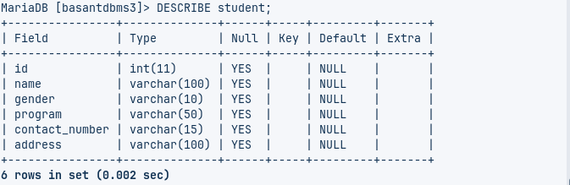

1. **DESCRIBE teacher;**

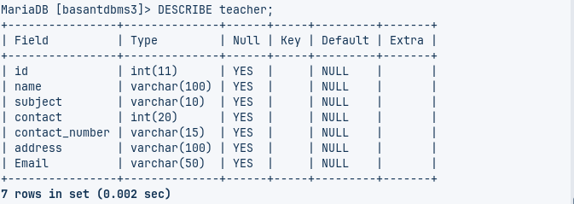

1. Insert Sample Data in tables
2. Insert into student:

Query:

1. Insert into teacher:

Query:

1. Check inserted data in tables;
2. For Student   
   Query:

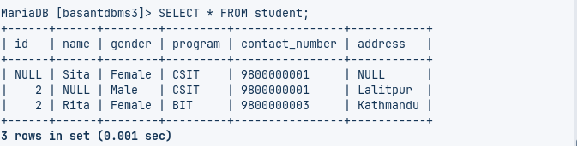

1. For teacher  
   Query:

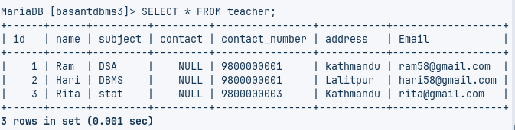

1. Add NOT NULL Constraints
2. Add NOT NULL Constraint in student table for necessary attributes  
   Query:  
     
   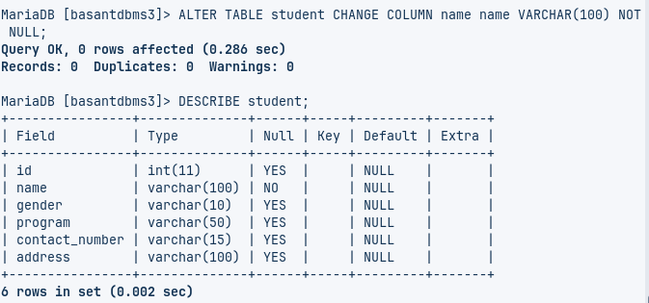
3. Add NOT NULL Constraint in teacher table for necessary attributes

Query:

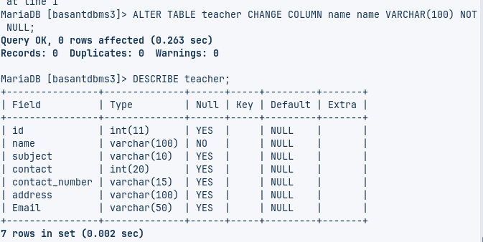

1. Test violation of NOT NULL Constraint in tables by INSERTING NULL values

Query:



1. Add UNIQUE Constraints (Require deletion of previous duplicate data)
2. DELETE FROM <tablename>  
   Query:



1. Add UNIQUE Constraint in student table for necessary attributes

Query:

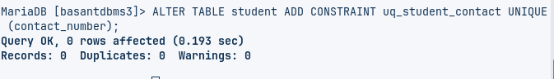

1. Add UNIQUE Constraint in teacher table for necessary attributes

Query:

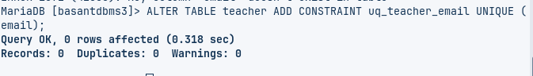

1. Test violation of UNIQUE Constraint in tables by INSERTING DUPLICATE values  
   Query:



1. Set DEFAULT Values
2. Add DEFAULT Value in student table for necessary attributes

Query:

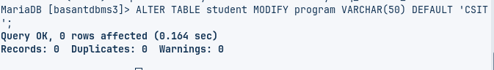

1. Add DEFAULT Value in teacher table for necessary attributes

Query:

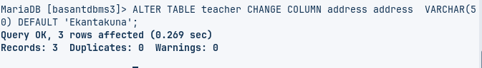

1. Set PRIMARY KEYS
   1. Add PRIMARY KEY in student table  
      Query:

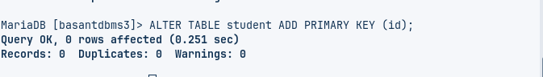

* 1. Add PRIMARY KEY in teacher table  
     Query:  
       
     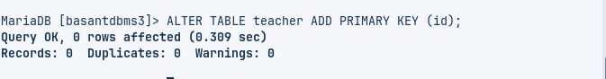

1. Add ENUM and CHECK Constraints
2. Add ENUM  
   Query:

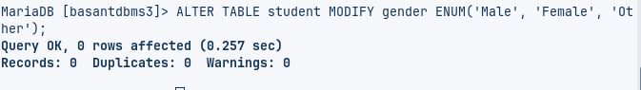

And CHECK Constraints in student table  
 Query:

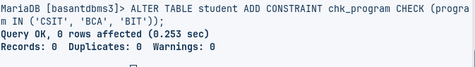

1. Add ENUM

Query:

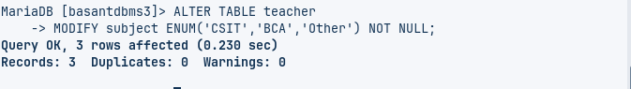

And CHECK Constraints in teacher table  
Query:

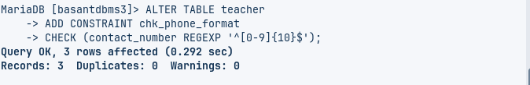

1. Test ENUM and CHECK Constraints in by INSERTING different values than enum and check values in respective attributes:   
   Query:

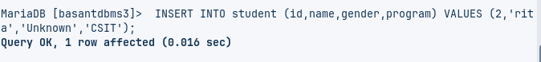

Query:



Query:



1. List all Constraints  
    Query:

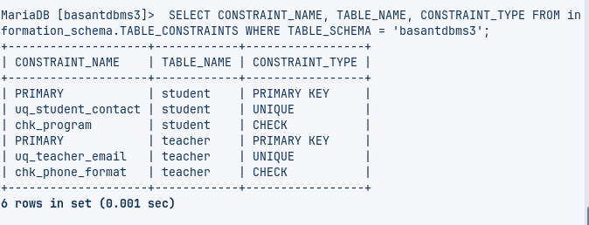

1. Delete All Constraints from tables;
2. DROP Constraints from student table  
   Query:

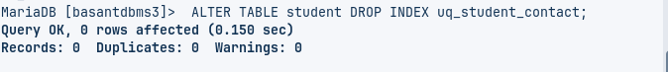

1. DROP Constraints from teacher table  
    Query:

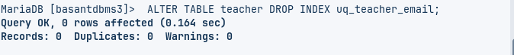

1. Test deletion of Constraints in by inserting values having duplicates in respective attributes  
   Query:

